EXPERT SYSTEM FOR MEDICAL DIAGNOSIS

USECASE DIAGRAM
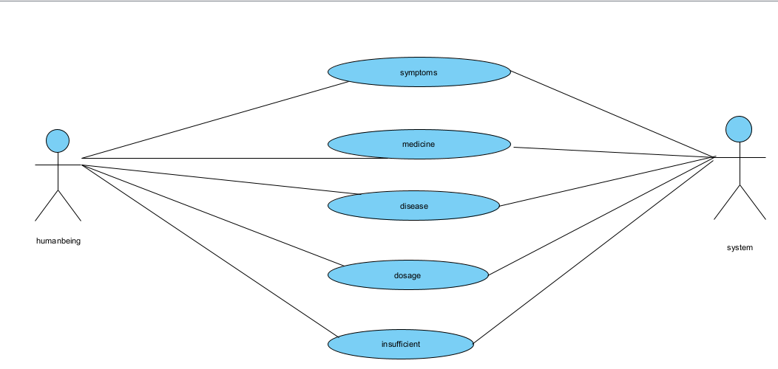

ACTIVITY DIAGRAM
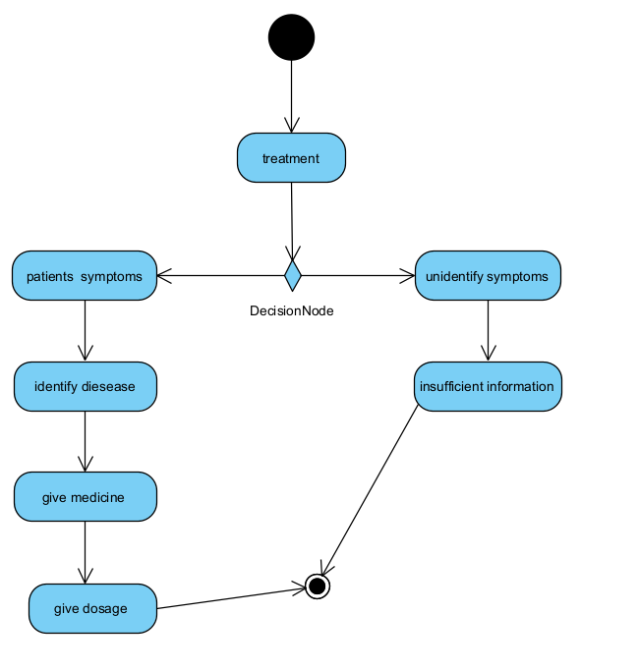

SEQUENCEN DIAGRAM
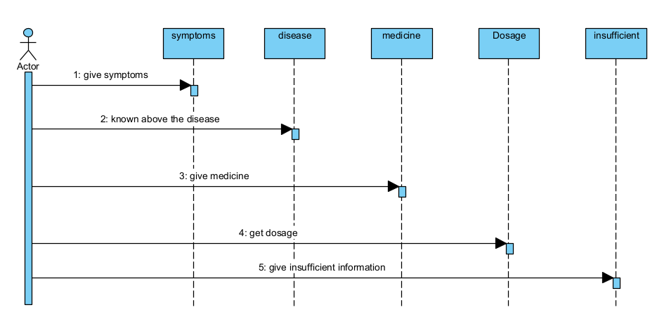

CLASS DIAGRAM
